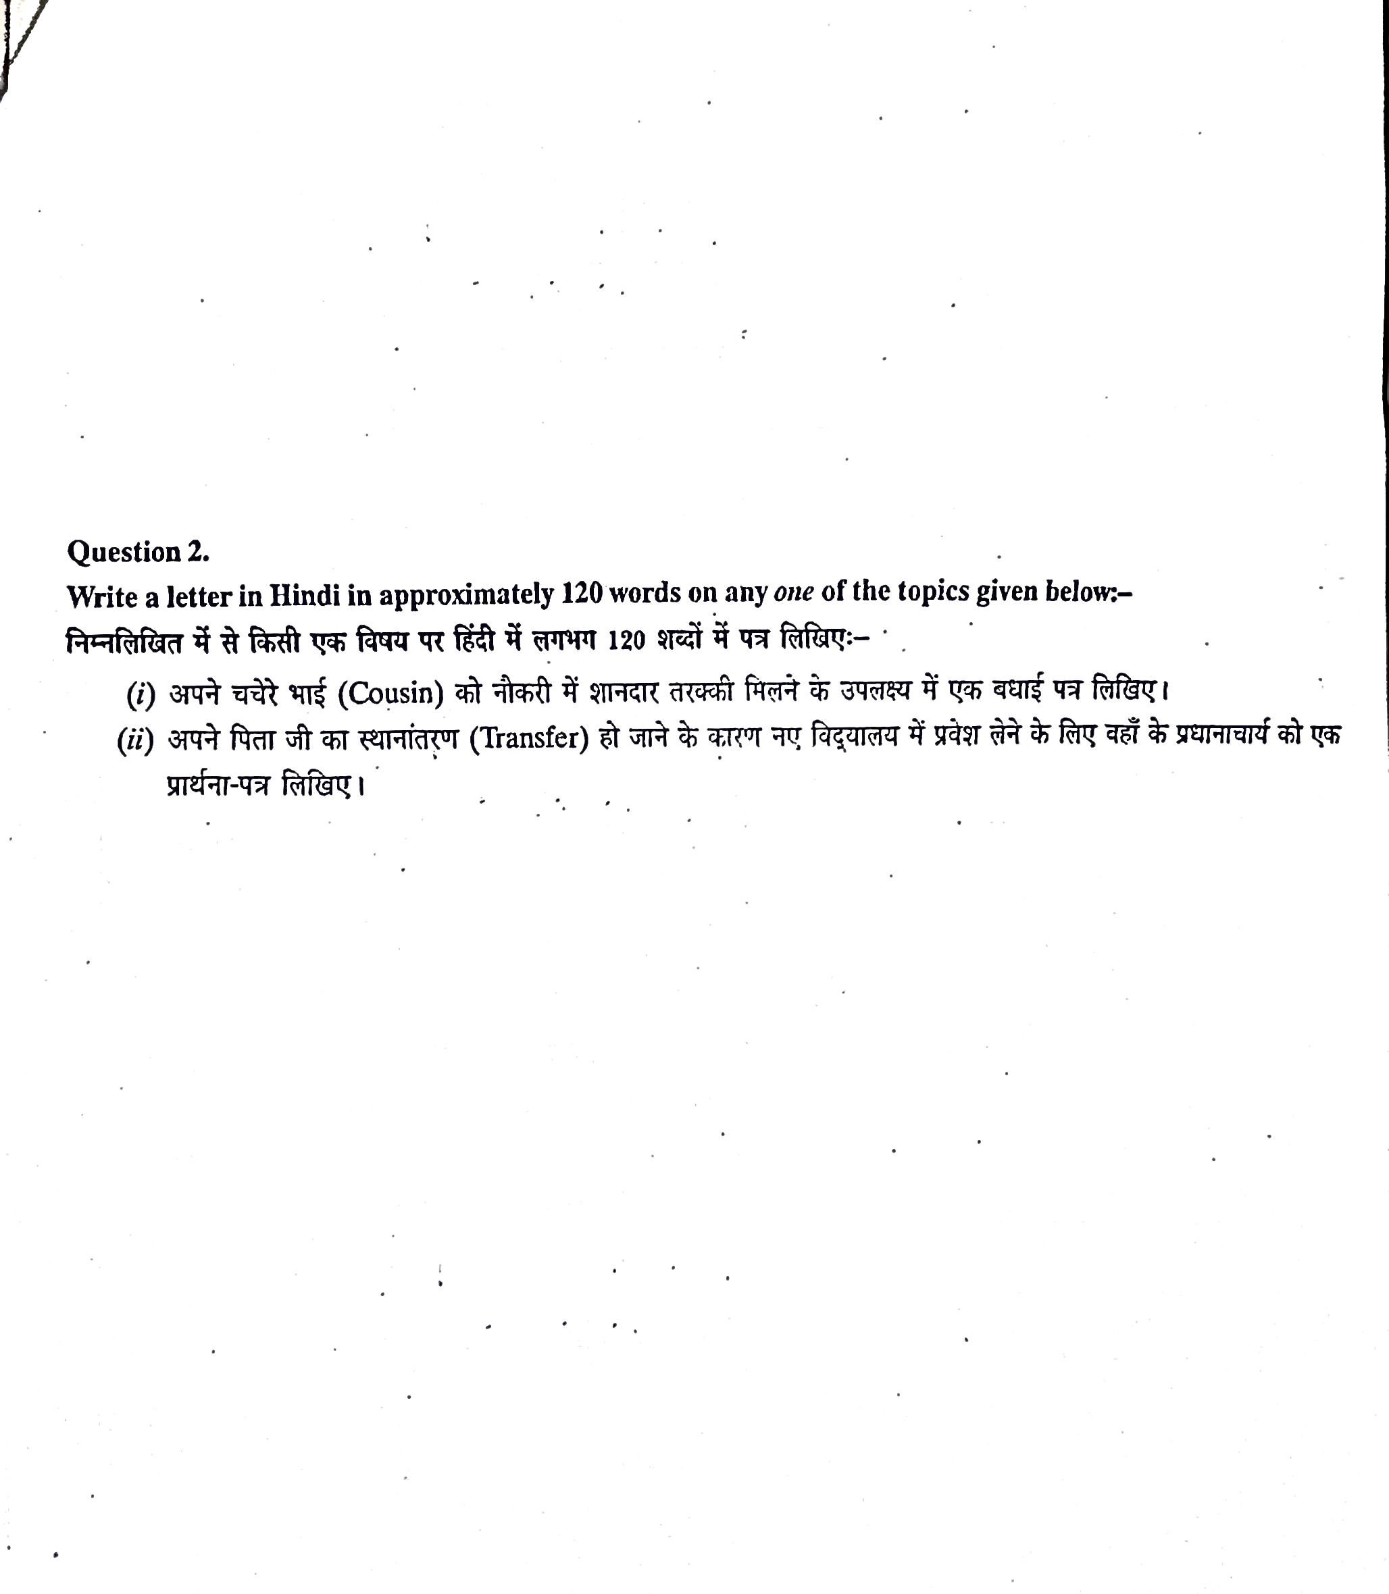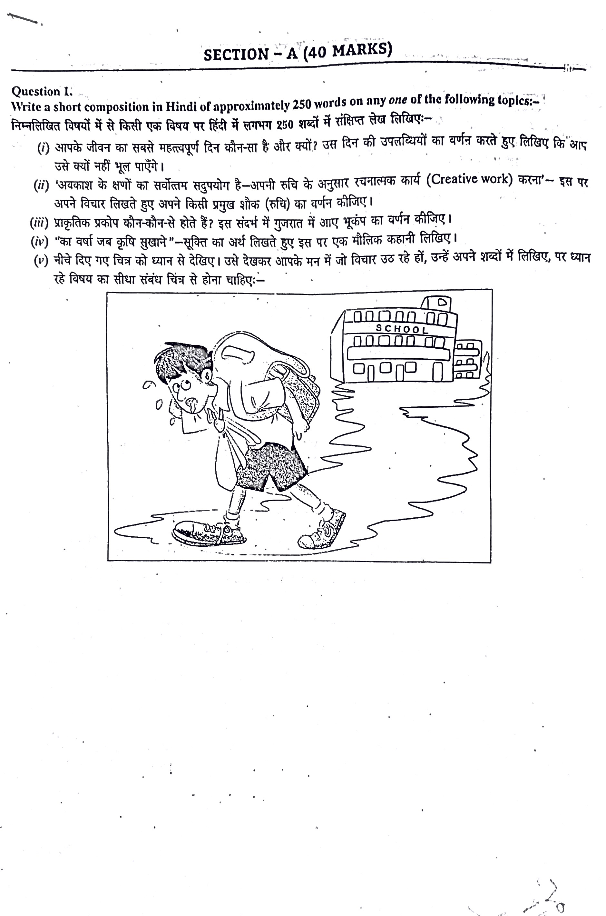

Mock paper - 1

GUIDELINES

(By Subrata Sir & group of ICSE and CBSE school teachers)

